The heart of Newcastle city centre is almost entirely Classical. Much of it was built by Richard Grainger, between 1824 and 1841.

If you walk down Grey Street, you will see many buildings that reference the Classical past.

Look out for Doric, Ionic and Corinthian columns and pilasters (flattened decorative columns).

Grey’s Monument is 41.5m tall. It was erected in 1838. It was originally going to be put on the Town Moor.

The column is Roman Doric. You can see the column drums and egg and dart moulding at the top of the column. This is a Classical motif.

The column celebrates Earl Grey’s championing of Parliamentary reform. There were many victory columns in ancient Greece and Rome.

This monument, erected in 1907, commemorates the Boer War 1899-1902.

It combines the Classical winged victory (Nike) on top of the monument with a personification of Northumberland at the base.

On the column you can see a bundle and axe (fasces). This was a Roman symbol of authority.

The inscription in Latin translates as ‘How Sweet and Proper it is to Die for Your Country’. This was originally from Ode 3.2 of the Roman poet Horace, but made famous by the First World War poet Wilfred Owen.

**CLASSICAL WALKING TOUR ITINERARY**

Begin at Haymarket – End at Central Station

1. Victory Monument Haymarket

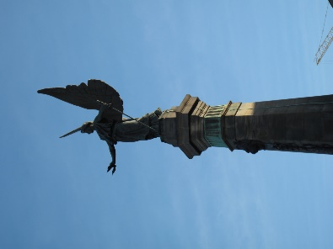

1. Grey’s Monument
2. Grey Street

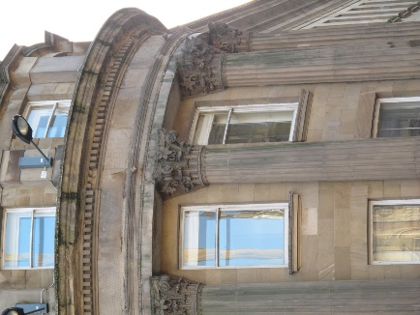

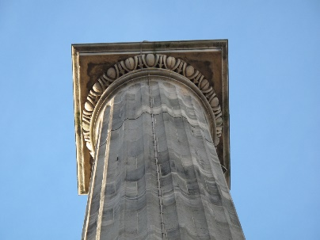

Other elements of Classical architecture to spot in Grey Street:

* Palmette acroteria

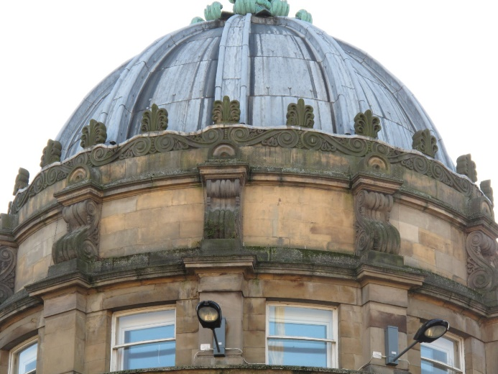

* Wreaths (Lloyds Bank)

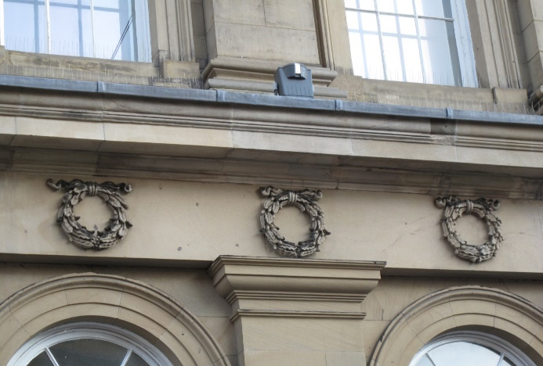

* Urns (Theatre Royal)

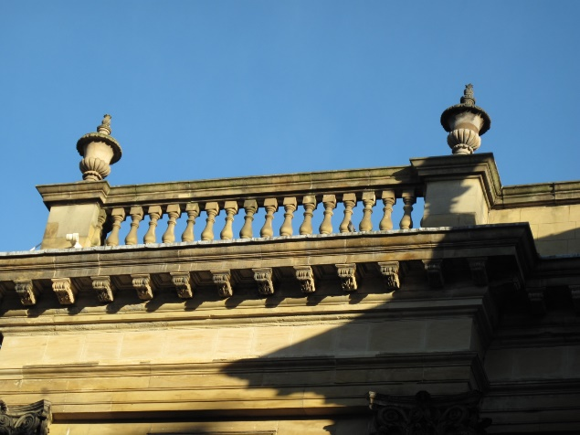

* An optional detour

Just above the Quayside, All Saints Church was built 1786-1796.

It has a portico with Greek Doric columns and Roman capitals. The portico has a frieze and pediment. To the side of the pediment you can see Ionic pilasters.

Also notice the urn above the pediment.

The Theatre Royal was built 1836-1837.

The portico is like the front of a Greek temple. Notice the Corinthian columns and the triangular pediment above them. Urns also feature as acroteria on the roof.

Corinthian columns are especially flamboyant and well suited to a theatre.

Central Arcade was built in 1906.

Classical motifs to spot:

* Niches
* Egg and dart moulding
* Ionic and Corinthian columns
* Greek key pattern on the renewed floor mosaic

1. Central Arcade

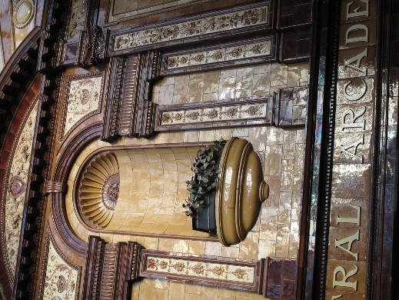

1. Theatre Royal

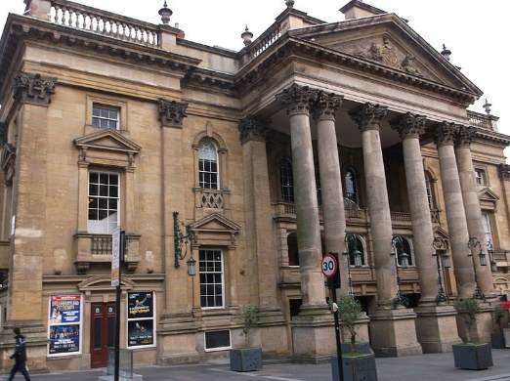

1. All Saints Church

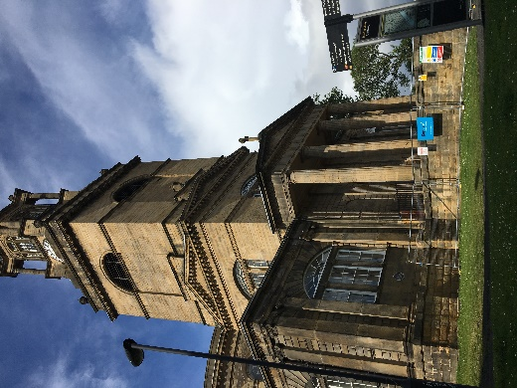

As you walk along St Nicholas’ Street towards Central Station stop and look at the Old Post Office building on left. It was built 1873-1876.

It has giant columns and pilasters.

The Moot Hall was built 1810-1812 as the County Court and prisons for Northumberland.

Here we see the most severe style of Greek revival architecture (suited to the function of the building).

Notice the Doric columns set on a stylobate like a Greek temple, as well as the pediment and Doric frieze.

**Use the Greek Architecture worksheet here**

This is a complex building. The main structure was built in 1665. The east end was rebuilt 1823-1825 in the Greek style.

The building served as a court council chamber on the first floor and an exchange and weigh house below.

Notice the Doric columns and Doric frieze. You can clearly see the metopes and triglyphs. The guttae below the triglyphs look like lego blocks, as do the mutules on the overhang above.

1. The Guildhall

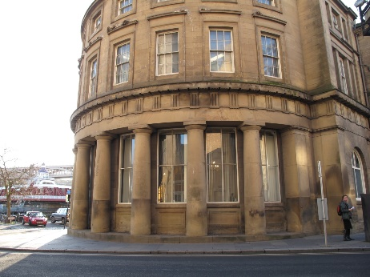

1. The Moot Hall

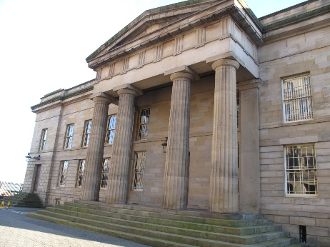

1. The Old Post Office

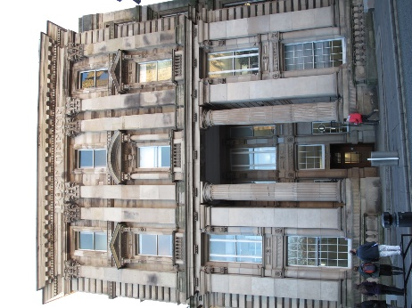

* An optional detour

The Assembly Rooms were built 1874-1876.

Notice the pediment and giant unfluted Ionic columns.

The building housing Central Station was opened by Queen Victoria and Prince Albert in 1850.

There are a number of Classical elements, including a Doric frieze with metopes and triglyphs, as well as Doric pilasters on either side of the arches.

Just along from Central Station, on Collingwood Street, you can see the ‘Lit and Phil’ building. It was built 1822-1825.

It has a pedimented Greek revival front.

The lecture theatre inside was the first public room to be lit by electric light in 1880. If you go inside you can see copies of the Parthenon metopes on the staircase.

1. The Literary and Philosophical Society

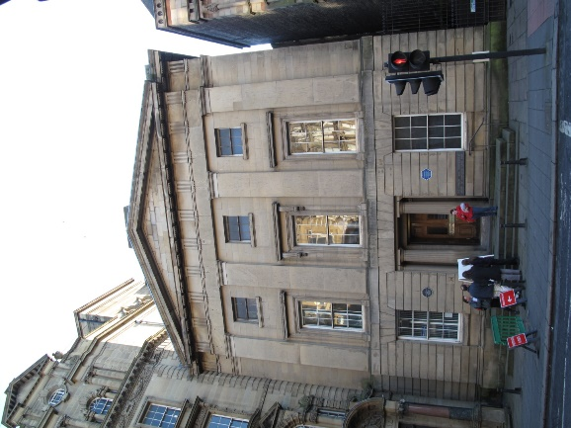

1. Assembly Rooms

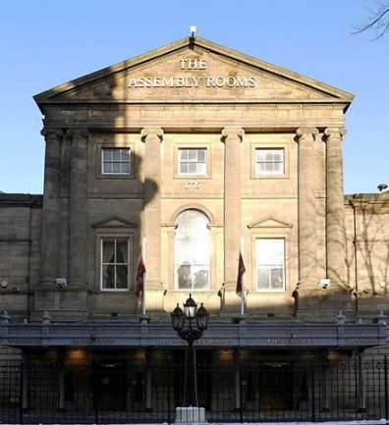

1. Central Station

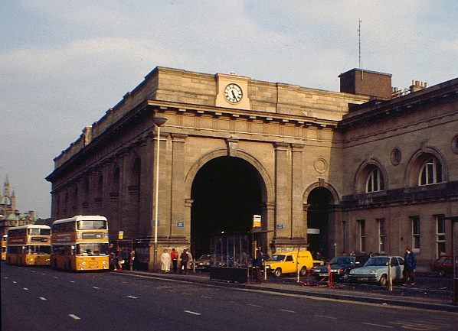

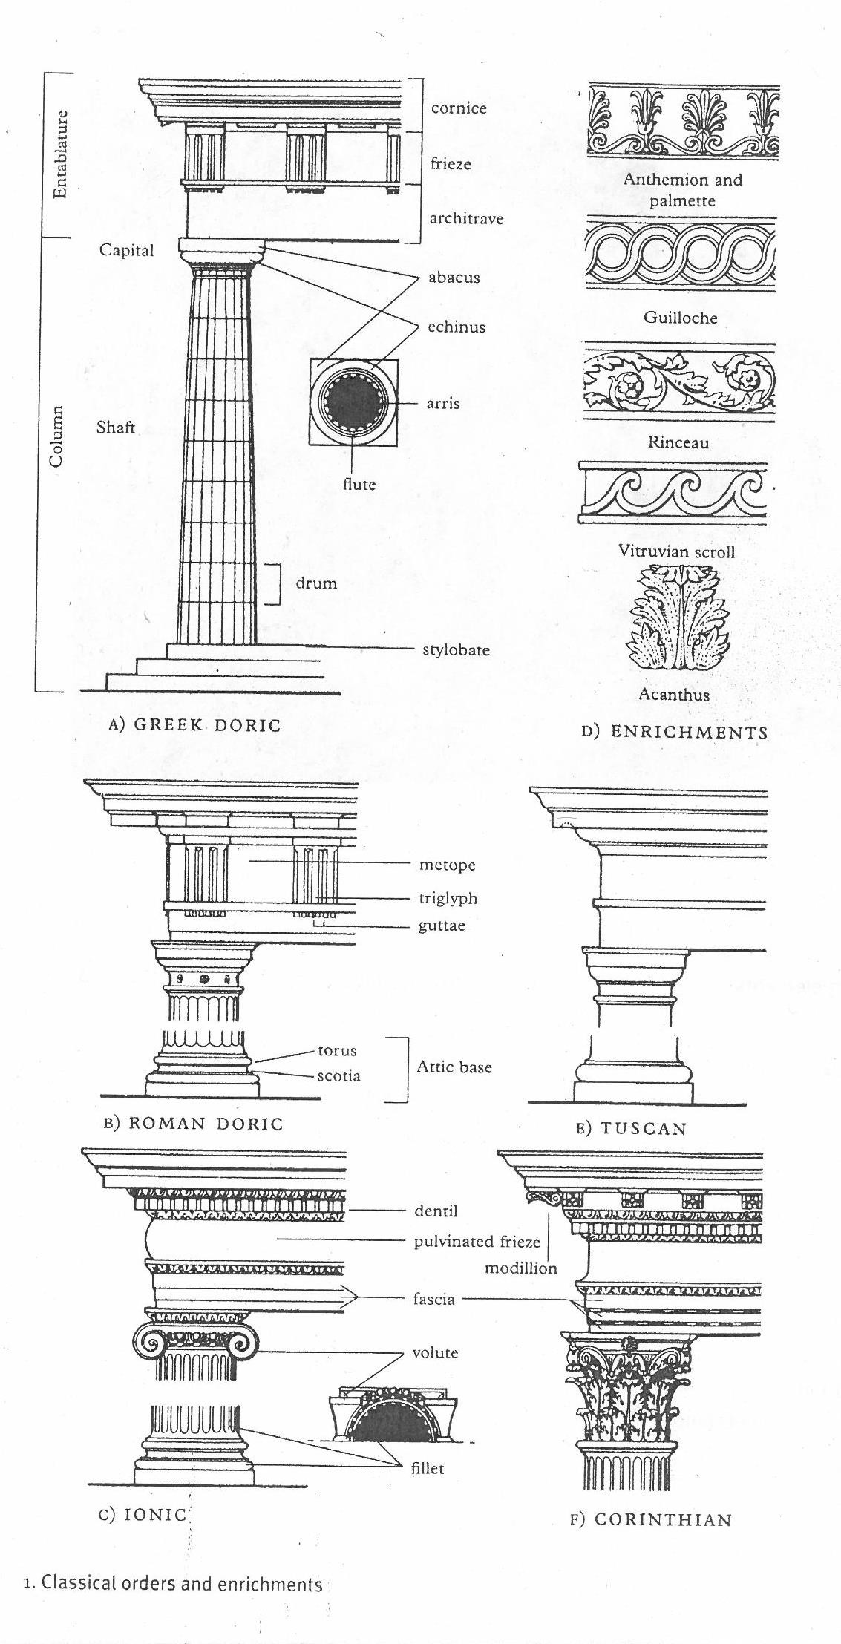

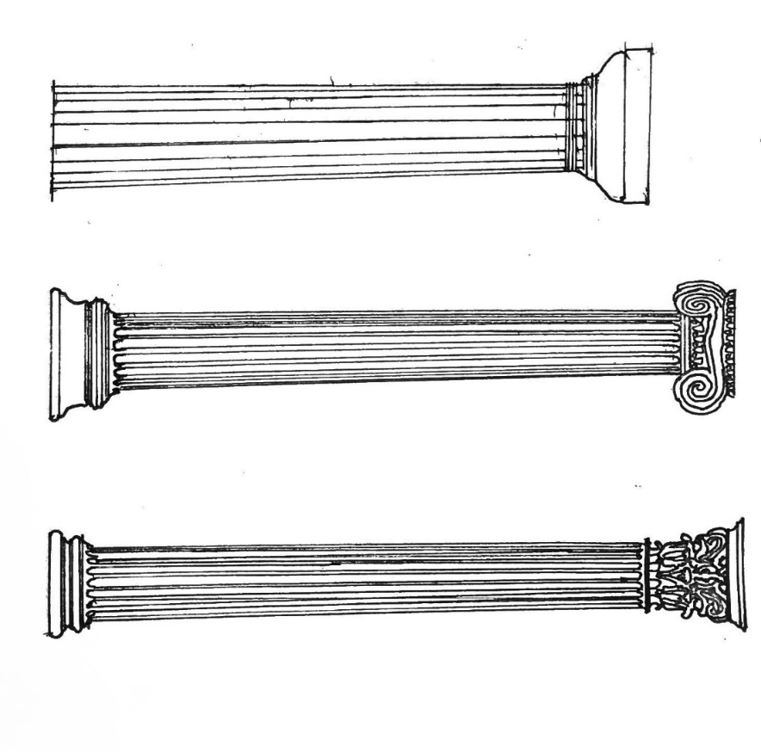

Greek column orders (styles):

Left – Doric

Middle – Ionic

Right – Corinthian